**EXPERIMENT 1**

**NUMERICAL INTEGRATION METHOD**

**1.Trapezoidal Method**

**CASE 1:**

**CODE**

clc

clear all

f=@(x) x^2;

p=input ("enter the lower limit= ");

q=input ("enter the upper limit= ");

i=input ("enter the intervals= ");

h=(q-p)/i;

f0=f(p);

fn=f(q);

res=0;

%Trapezoidal method formula

for j=p+h:h:q-h

F=f(j);

res=res+2*F;

end

Trap = h*(f0+res+fn)/2

**OUTPUT**

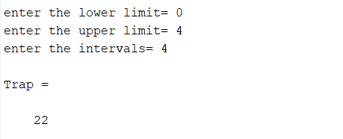

**CASE 2:**

**CODE**

clc

clear all

f=@(x) exp(-x^2/2)/sqrt(2*pi);

p=input("enter the lower limit= ");

q=input("enter the upper limit= ");

i=input("enter the intervals= ");

h=(q-p)/i;

f0=f(p);

fn=f(q);

res=0;

%trapezoidal method formula

for j=p+h:h:q-h

F=f(j);

res=res+2*F;

end

Trap = h*(f0+res+fn)/2

**OUTPUT**

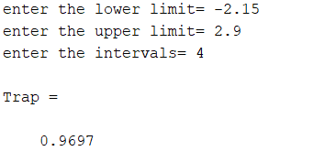

**2.Simpson’s 1/3 Method**

**CASE 1:**

**CODE**

clc

clear all

f=@(x) x^2;

p=input("enter the lower limit= ");

q=input("enter the upper limit= ");

i=input("enter the intervals= ");

h=(q-p)/i;

f0=f(p);

fn=f(q);

res=0;

k=1;

%simpson's one third rule

for j=p+h:h:q-h

F=f(j);

if rem(k,2)==0

res=res+ 2*F;

else

res=res+4*F;

end

k=k+1;

end

SimpOneThird = h*(f0+res+fn)/3

**OUTPUT**

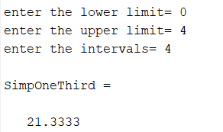

**CASE 2:**

**CODE**

clc

clear all

f=@(x) exp(-x^2/2)/sqrt(2*pi);

p=input ("enter the lower limit= ");

q=input ("enter the upper limit= ");

i=input ("enter the intervals= ");

h=(q-p)/i;

f0=f(p);

fn=f(q);

res=0;

k=1;

%Simpson’s one third rule

for j=p+h:h:q-h

F=f(j);

if rem(k,2)==0

res=res+ 2*F;

else

res=res+4*F;

end

k=k+1;

end

SimpOneThird = h*(f0+res+fn)/3

**OUTPUT**

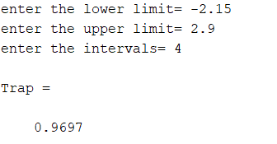

**3.Simpson’s 3/8 Method**

**CASE 1:**

**CODE**

clc

clear all

f=@(x) x^2;

p=input("enter the lower limit= ");

q=input("enter the upper limit= ");

i=input("enter the intervals= ");

h=(q-p)/i;

f0=f(p);

fn=f(q);

res=0;

k=1;

%simpson's third by eight rule

for j=p+h:h:q-h

F=f(j);

if rem(k,3)==0

res=res+2*F;

else

res=res+3*F;

end

k=k+1;

end

SimpThreeByEight = 3*h*(f0+res+fn)/8

**OUTPUT**

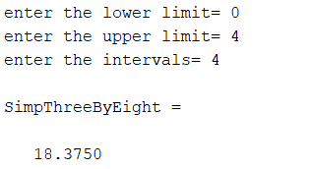

**CASE 2:**

**CODE**

clc

clear all

f=@(x) exp(-x^2/2)/sqrt(2*pi);

p=input("enter the lower limit= ");

q=input("enter the upper limit= ");

i=input("enter the intervals= ");

h=(q-p)/i;

f0=f(p);

fn=f(q);

res=0;

k=1;

%simpson's third by eight rule

for j=p+h:h:q-h

F=f(j);

if rem(k,3)==0

res=res+2*F;

else

res=res+3*F;

end

k=k+1;

end

SimpThreeByEight = 3*h*(f0+res+fn)/8

**OUTPUT**

